# Binary Search

Understand Binary Search

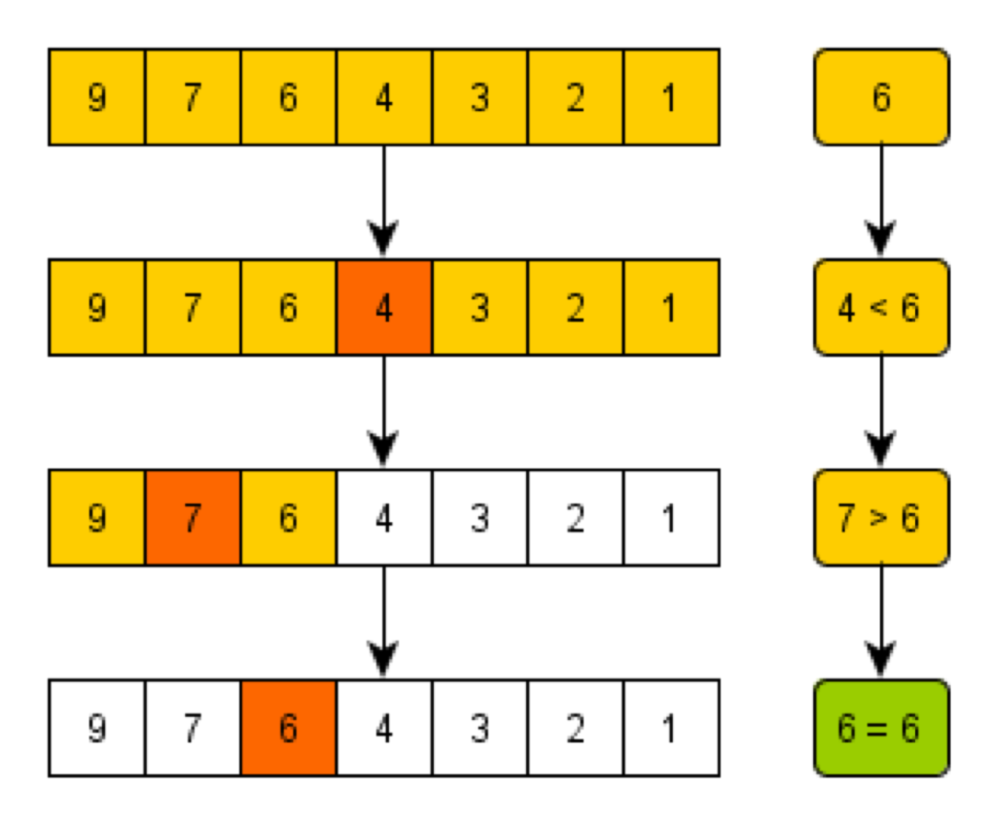

## Problem: To find if n is a square of an integer

if(mid*mid==x):

return mid

else if (mid*mid>x):

binary_search(left,mid-1)

else:

binary_search(mid+1,right)

## Other Problems to try:

Find the frequency of a given target value in an array of integers

Find the peak of an array that increases and then decreases

A sorted array is rotated n times. Search for a target value in the array.